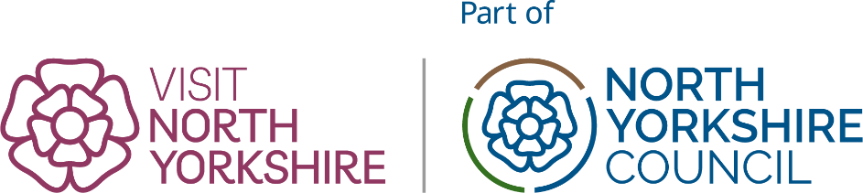

Listing Update Form: Retail
Your Name: | Listing name:

please paste the web address of the listing you are updating from visitnorthyorkshire.com

Listing URL:

You will need to know what level of listing you have if you are not sure, contact us.

Complete all the sections where your business profile requires an update and then send your completed form to biz@visitnorthyorkshire.com

1.Business & Contact Details (public facing)
☐ All Details Correct
☐ Update needed (complete changes below)
Business Name |  |  | E-Mail
Address |  |  | Web
Postcode |  |  | Telephone (landline)
Revise Map Pin?
please describe or paste screengrab

Please continue to the next page

2.Business Description (All partner levels)

☐ All Details Correct
☐ Update needed (provide FULL revised descriptions below)
Please provide ALL the text for your description, not just changes. Your entire description will be replaced with the copy you provide.
Intro Sentence (30 words maximum)
Long Description

To help make text easy for visitors to interpret and find specific information they are looking for, we recommend the use of section headers.

Text Allowance (characters inc spaces)Silver: 1500
Gold &Platinum: Unlimited
Please continue to the next page

3. Images (All partner levels)
☐ All Details Correct
☐ Update needed (I will send images separately)
Please Note: It is your responsibility to own the copyright on any images, or to ensure that they have appropriate licences from any and all third parties who may be the owner of the respective copyright.
Visit North Yorkshire is not responsible for any material provided by a partner or advertiser in breach of copyright or any other intellectual copyright. In the event of such a breach the sole responsibility shall remain with you the Advertiser.

Your image allowance varies by Profile Level:
Silver 6 images
Gold 10 images
Platinum 15 images
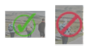
Images must be landscape in orientation as shown here >
Minimum image requirements: 1200pixels by 800pixels.

We cannot accept posters/graphics/logos as images for a business profile page. Such images will not display well and on some devices will be cropped making them illegible.

Platinum profiles: If you are sending an image for your header image (full width hero image) these should be sized 1920pixels by 1080pixels.

Please continue to the next page

4. New Feature: FAQs (All Levels)
Are there questions you know visitors often have about your business?
Help visitors find out everything they need both on visitnorthyorkshire.com and in search engines and AI Search by including them in your listings. FAQs can be new information or can highlight information already in your listing that people may miss.
Please keep answers to one sentence long.
Question 1:
Answer 1:
Question 2:
Answer 2:
Question 3:
Answer 3:
Question 4:
Answer 4:
Question 5:
Answer 5:
Please continue to the next page

5.Opening Times
☐ All Details Correct
☐ Update needed (complete changes below)
If your opening times are more complex than the table allows please enter into your long description.
Opening Days & Times
Monday | From | To
Tuesday | From | To
Wednesday | From | To
Thursday | From | To
Friday | From | To
Saturday | From | To
Sunday | From | To

6.Sustainability Criteria (All levels)
☐ All Details Correct
☐ Update needed (complete changes below)
Are you a certified member of a Green Accreditation organisation? |  | ☐
If Green Tourism (please provide URL to member listing) | URL:
Other:

Sustainability features of your business
Sustainability policy |  | ☐
EV Charging points |  | ☐
Accessible by public transport |  | ☐
Net Zero pledge |  | ☐
Locally sourced food or produce |  | ☐
Plant based menu options |  | ☐
Onsite recycling separation |  | ☐

Please continue to the next page

7.Accessibility (All levels)
☐ All Details Correct
☐ Update needed (complete changes below)
Visit North Yorkshire is part of a drive to put our North Yorkshire towns and places at the forefront of the Government’s ambition for the UK to become one of the most accessible destinations in Europe.

Download the Accessible North Yorkshire toolkit to find out how to create your own accessibility information page: Toolkit - Google Drive

For more information and help about accessibility options please email biz@visitnorthyorkshire.com

Email address for who we should contact about your accessibility options: | Email:
Please provide a link to the following options, where applicable:
Your own accessibility information page (see toolkit for details of how to create your own)
Your Accessible access guide and profile
Your Accessible UK audit/web page

Please continue to the next page

8.Social Media Links (Gold & Platinum Only)
☐ All Details Correct
☐ Update needed (complete changes below)
Channel | Website URL
TripAdvisor
Instagram
Facebook
X / Twitter
TikTok
YouTube

9. Facilities (Gold and Platinum ONLY)
☐ All Details Correct
☐ Update needed (complete changes below)
To help us ensure your listing is accurate, if submitting a change, please complete this section IN FULL, do not just add new entries.
Any unchecked boxes will not appear on your listing.
☐ Dogs Accepted
☐ Dogs not accepted (except guide dogs)
☐ Chair or seating for customers
☐ Dedicated parking (This would not include public street parking or nearby car parks)

By completing and returning this form you are agreeing to Visit North Yorkshire’s Terms & Conditions and the Visit North Yorkshire Quality Charter.

You may now return this form along with any images to biz@visitnorthyorkshire.com

