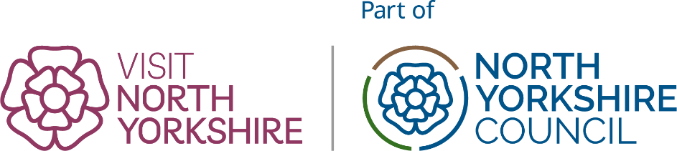

Listing Update Form: Self Catered Accommodation
Use this form for Cottages, chalets, lodges and static caravans (holiday hire)
Your Name: | Business name:

Paste the web address of the profile page you are updating from visitnorthyorkshire.com

Listing URL:

To complete this form please make sure you know the level of your Business Profile Page, this will be Silver, Gold or Platinum. For Bronze profiles please use the quick online form.

Please only complete the sections you are updating. If requesting changes complete that section in full. Pages will reflect the contents of each section including blank fields.

1. Business contact details (All partner levels)
☐ All Details Correct
☐ Update needed (provide FULL details below)
Business Name |  |  | E-Mail
Address |  |  | Web
Postcode |  |  | Telephone
Revise Map Pin?
please describe or paste screengrab

Please continue to the next page

2.Business Description (All partner levels)
☐ All Details Correct
☐ Update needed (provide FULL revised descriptions below)
Please provide ALL the text for your description, not just changes. Your entire description will be replaced with the copy you provide.
Intro Sentence (30 words maximum)
Long Description

To help make text easy for visitors to interpret and find specific information they are looking for, we recommend the use of section headers.

Text Allowance (characters inc spaces) Silver: 1500
Gold &Platinum: Unlimited
Please continue to the next page

3. Images (All partner levels)
☐ All Details Correct
☐ Update needed (I will send images separately)
Please Note: It is your responsibility to own the copyright on any images, or to ensure that they have appropriate licences from any and all third parties who may be the owner of the respective copyright.
Visit North Yorkshire is not responsible for any material provided by a partner or advertiser in breach of copyright or any other intellectual copyright. In the event of such a breach the sole responsibility shall remain with you the Advertiser.

Your image allowance varies by Profile Level:
Silver 6 images
Gold 10 images
Platinum 15 images
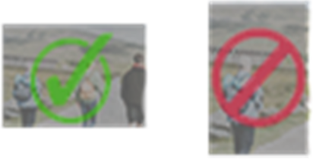
Images must be landscape in orientation as shown here >
Minimum image requirements: 1200pixels by 800pixels.

We cannot accept posters/graphics/logos as images for a business profile page. Such images will not display well and on some devices will be cropped making them illegible.

Platinum profiles: If you are sending an image for your header image (full width hero image) these should be sized 1920pixels by 1080pixels.

Please continue to the next page

4. New Feature: FAQs (All partner levels)
Are there questions you know visitors often have about your business?
Help visitors find out everything they need both on visitnorthyorkshire.com as well as in search engines and AI Search by adding FAQs to your page.
FAQs can be new information or can highlight information already in your business profile that people may miss.
Please keep answers to one or two sentences long.

Question 1:
Answer 1:
Question 2:
Answer 2:
Question 3:
Answer 3:
Question 4:
Answer 4:
Question 5:
Answer 5:

Please continue to the next page

5.Sustainability Criteria (All partner listings)
☐ All Details Correct
☐ Update needed (complete changes below)
Are you a certified member of a Green Accreditation organisation? | ☐
If Green Tourism, URL:
Other:
Sustainability features of your business
Sustainability policy | ☐
EV Charging points | ☐
Accessible by public transport | ☐
Net Zero pledge | ☐
Locally sourced food or produce | ☐
Plant based menu options | ☐
Onsite recycling separation | ☐

6.Accessibility (All partner listings)
☐ All Details Correct
☐ Update needed (complete changes below)
Visit North Yorkshire is part of a drive to put our towns and places at the forefront of the Government’s ambition for the UK to become one of the most accessible destinations in Europe.

Accessible North Yorkshire can help you create your own accessibility information page. Find out more about Accessible North Yorkshire.
For more information and help about accessibility options please email biz@visitnorthyorkshire.com

Email address for who we should contact about your accessibility options: | Email:
Please provide a link to the following options, where applicable: | URL
Your own accessibility information page (see toolkit for details of how to create your own)
Your Accessible access guide and profile
Your Accessible UK audit/web page
Please continue to the next page

7. Accommodation Info (All partner listings)
These fields are optional, but can help visitors. They are also part of the structured data we provide to search engines and AI models.
Price range (Per night) | from: | to:
Times | Check-in: | Check-out:

Your availability can be searched on www.visitnorthyorkshire.com.
Property Management System bookings will be subject to no charge from Visit North Yorkshire.
We can also add a direct booking link using TXGB or TXLoad (5% charge will apply)
Platform
Free to book ☐ | We will contact FreetoBook and request the VNY channel be added for you, it will then appeal in your Free to Book screen and you can opt out at any time
Bookalet ☐ | Please add the Visit North Yorkshire channel
Super Control ☐ | Please add the Visit North Yorkshire channel
TXGB/TXLoad ☐ | Please select the Visit North Yorkshire Silver + option.

Please continue to the next page

8.Social Media Profiles (Gold & Platinum partners only)
☐ All Details Correct
☐ Update needed (complete changes below)
Channel | Website URL links
TripAdvisor
Instagram
Facebook
X / Twitter
TikTok
YouTube

9. Facilities (Gold & Platinum partners only)
☐ All Details Correct
☐ Update needed (complete changes below)
To help us ensure your listing is accurate, if submitting a change, please complete this section IN FULL, do not add new entries.
Any unchecked boxes will not appear on your listing
☐ Children welcome | ☐ Bath
☐ Adults only | ☐ Shower
☐ Dogs accepted | ☐ Wood burner
☐ Dogs not accepted (except guide dogs) | ☐ Swimming pool
☐ Pet free accommodation | ☐ Private parking
☐ Garden | ☐ EV charging on-site
☐ Hot tub | ☐ Secure cycle storage

By completing and returning this form you are agreeing to Visit North Yorkshire’s Terms & Conditions and the Visit North Yorkshire Quality Charter.

You may now return this form along with any images to biz@visitnorthyorkshire.com

