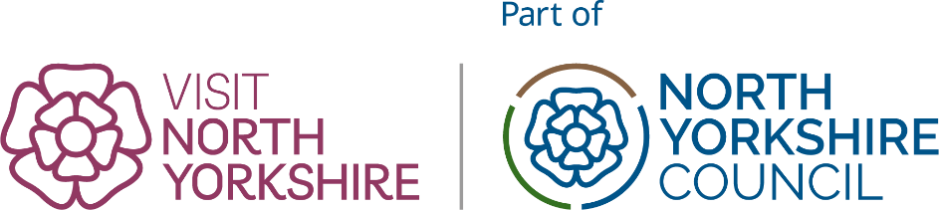

Listing Update Form: Serviced Accommodation
Use this form for Hotels, Guesthouses and Bed & Breakfasts
Your Name: | Listing name:

please paste the web address of the listing you are updating from visitnorthyorkshire.com

Listing URL:

You will need to know what level of listing you have - if you are not sure, contact us.

Please only complete the sections you wish to update. If you complete a section, complete it in full, your updated listing will reflect all fields both empty and populated.

1. Business contact details - public (All partner listings)
☐ All Details Correct
☐ Update needed (complete changes below)
Business Name |  |  | E-Mail
Address |  |  | Web
Postcode |  |  | Telephone (landline)
Revise Map Pin?
please describe or paste screengrab

2. Images (All partner listings)
☐ All Details Correct
☐ Update needed (I will send images separately)
Provide revised images, a reminder of your image allowance

Silver listing: 6 images
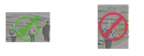
Gold listing: 10 images
Platinum listing: 15 images

Images must be landscape in orientation as shown here:
Minimum image requirements: 1200pixels by 800pixels.

Listing Hero Image: (Platinum listings only)
Please provide in landscape format, minimum 1920 pixels x 1080pixels

3.Business Description (All partner listings)
☐ All Details Correct
☐ Update needed (provide FULL revised description below)
Please send ALL the text for description not just changes sections. Your entire description will be replaced with the copy you provide.
Intro Sentence (250 Characters Max including spaces)
Long Description
Text Allowance (characters inc spaces)
Silver: 1500
Gold &Platinum: Unlimited

4. New Feature: FAQs (All partner listings)

Are there questions you know visitors often have about your business?
Help visitors find out everything they need both on visitnorthyorkshire.com and in search engines and AI Search by including them in your listings. FAQs can be new information or can highlight information already in your listing that people may miss.
Please keep answers to one sentence long.
Question 1:
Answer 1:
Question 2:
Answer 2:
Question 3:
Answer 3:
Question 4:
Answer 4:
Question 5:
Answer 5:

5.Sustainability Criteria (All partner listings)
☐ All Details Correct
☐ Update needed (complete changes below)
Are you a certified member of a Green Accreditation organisation? | ☐
If Green Tourism, URL:
Other:
Sustainability features of your business
Sustainability policy | ☐
EV Charging points | ☐
Accessible by public transport | ☐
Net Zero pledge | ☐
Locally sourced food or produce | ☐
Plant based menu options | ☐
Onsite recycling separation | ☐

6.Accessibility (All partner listings)
☐ All Details Correct
☐ Update needed (complete changes below)
Visit North Yorkshire is part of a drive to put our towns and places at the forefront of the Government’s ambition for the UK to become one of the most accessible destinations in Europe.

Accessible North Yorkshire can help you create your own accessibility information page. Find out more about Accessible North Yorkshire. For more information and help about accessibility options please email biz@visitnorthyorkshire.com

Email address for who we should contact about your accessibility options: | Email:
Please provide a link to the following options, where applicable: | URL
Your own accessibility information page (see toolkit for details of how to create your own)
Your Accessible access guide and profile
Your Accessible UK audit/web page

7. Accommodation Info (All partner listings)
These fields are optional, but can help visitors. They are also part of the structured data we provide to search engines and AI models.
Price range (Per night) | from: | to:
Times | Check-in: | Check-out:
8.Social Media Profiles (Gold & Platinum partners only)
☐ All Details Correct
☐ Update needed (complete changes below)
Channel | Website URL links
TripAdvisor
Instagram
Facebook
X / Twitter
TikTok
YouTube

9. Online Availability (Silver, Gold & Platinum partners only)
☐ All Details Correct
☐ Update needed (complete changes below)
Your business availability can be searched on www.visitnorthyorkshire.com.
Property Management System bookings will be subject to no charge from Visit North Yorkshire. For Silver listings above a 5% commission is applicable on TXGB and TX Load.
Platform
Free to book ☐ | We will contact FreetoBook and request the VNY channel be added for you, it will then appeal in your Free to Book screen and you can opt out at any time
Bookalet ☐ | Please add the Visit North Yorkshire channel
Super Control ☐ | Please add the Visit North Yorkshire channel
TXGB/TXLoad ☐ | Please select the Visit North Yorkshire Silver + option.

10. Facilities (Gold & Platinum partners only)
☐ All Details Correct
☐ Update needed (complete changes below)
To help us ensure your listing is accurate, if submitting a change, please complete this section IN FULL, do not add new entries.
Any unchecked boxes will not appear on your listing.

☐ Full English Breakfast | ☐ Licenced
☐ Continental Breakfast | ☐ Bar
☐ Dogs accepted | ☐ Evening meal
☐ Dogs not accepted (except guide dogs) | ☐ Swimming pool
☐ Pet free accommodation | ☐ Private parking
☐ Spa facilities | ☐ EV charging on-site
 | ☐ Secure cycle storage

By completing and returning this form you are agreeing to Visit North Yorkshire’s Terms & Conditions and the Visit North Yorkshire Quality Charter.

You may now return this form along with any images to biz@visitnorthyorkshire.com

